Adding the IP address with designated common name in the host file
Go to C:\Windows\system32\drivers\etc. Open Hosts file in notepad.
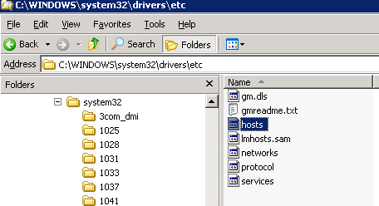

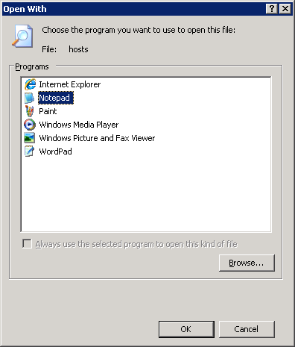
Type 222.127.150.236 SITXRSWEB
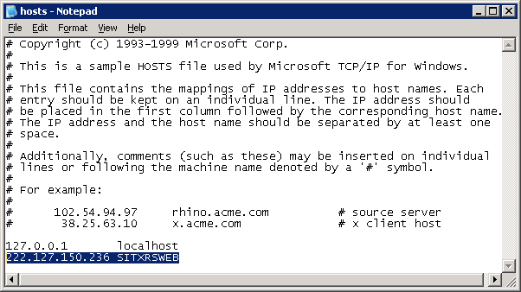
Close and save the changes.

You should be able to ping the SITXRSWEB 222.127.150.236.

This is for testing purposes only. After testing delete what you had entered.

